The Committee would like to invite you to Join us for a Botanica Christmas Brunch

Date: Sunday December 13, 2020
Time: 10.00am- 12 noon
Venue: Giro D’Italia Restaurant
401 St Kilda Rd, Melbourne
Cost: $33 per person***
*** includes: 1 glass of Prosecco & tea/coffee or juice.
Tap or Sparkling water & Choice of :
Muesli with Fruit & Yogurt
Big breakfast – Toast, Eggs, Bacon, Tomato & Mushrooms
Eggs on Toast – (with Bacon if desired)
Avocado Toast –(with or without eggs )
Pancakes with Berries & Mascarpone
Extras: Juice/Tea/Coffee $4.00 Prosecco $6 per glass
RSVP by 8/12/20: Margaret Ph 0409 691 203
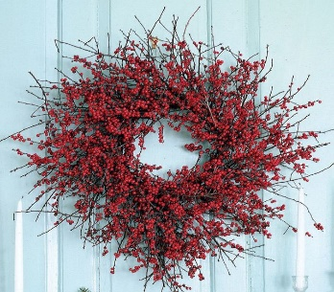 Join in our Christmas Wreath Competition:
Winner announced at the breakfast!
