Out of Hours Works Notification
South Melbourne
November 2022

CitiPower is relocating assets for the construction of the new Metro Tunnel Anzac Station Precinct.

Works
We’ll be completing overhead wire and underground cable works on St Kilda Road, within and adjacent to the ANZAC station precinct (as per the map overleaf).

When
These works are scheduled to be completed between Monday 7 November and Monday 28 November 2022.
Night works
- 3 nights – 9pm to 5am, Monday 7 to Wednesday 9 November 2022.
Day works
- 2 days – 7am to 5pm, Friday 18 and Monday 28 November 2022.

What to expect
- Electricity supply will be maintained, there are no planned outages during these works.
- Works will involve the removal and relocation of some public lighting, overhead wire and underground cables.
- Some of this work may be noisy.
- Local traffic and pedestrian access will be maintained at all times with traffic control in place to safely guide vehicles and pedestrians around the work area and through detours.
- Reinstatement of the area will be progressively completed after the completion of construction works.
- Work will be completed by CitiPower authorised contractor Service Stream.
- Works will be completed in stages and you will be notified by our authorised contractor of any further direct impacts.

Map of work area

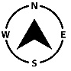
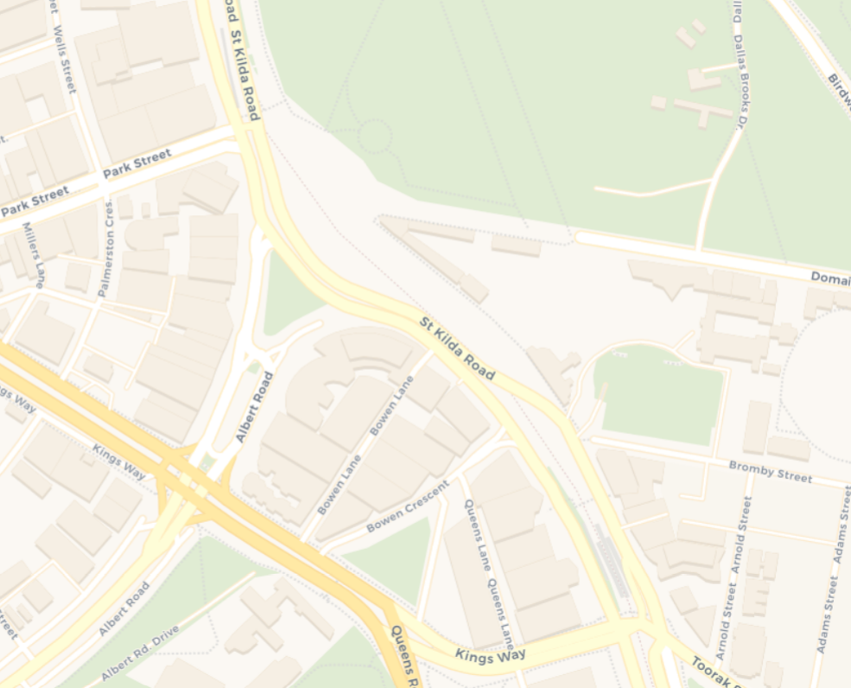
Work locations

Who are we?
CitiPower is your electricity distributor, we deliver electricity to a 157km square area across the Melbourne CBD and inner suburbs, we provide power to over 382,000 customers. Electricity is distributed in the area via a network of over 7,600km of lines and cables, supported by more than 58,100 poles and associated infrastructure. CitiPower is the most highly utilised and efficient CBD and urban network in the country.
